Planned dissemination activities of INBAS GmbH (Germany) within the “Complete” project
Organisation: | Complete | Partner N °: |  | INBAS |  | Period: |  |  |  |  | 01.10.2015- 30.09.2018 | Country: |  | Germany
Activities | Short description | Date(s)  Duration  Frequency | Place |  | Level |  |  |  |  |  | Characteristics of Target Group | Size / number of organisations / persons reached  (approximately) | Kind of documentation available
 |  |  |  |  | R |  |  | N | I
Add the project in the project database of the institute (done) | Information about the title, runtime, client and type of service | During and after the lifetime of the project |  | www.inbas.com | x |  | x |  |  | x | Co-operation partners, other stakeholders interested in the institutes activities | Not measurable | http://en.inbas.com/project-data-base/eu.html  Printscreen of website
Add information to web page of the institute | Information about the project, it`s aims, partners etc. | During and after the lifetime of the project |  | www.inbas.com | x |  | x |  |  | x | Co-operation partners, other stakeholders interested in the institutes activities | Not measurable | http://en.inbas.com/project-data-base/eu.html  Printscreen of website
Add project flyer to web page of the institute | Information about the project, it`s aims, partners etc. | During and after the lifetime of the project |  | www.inbas.com | x |  | x |  |  | x | Co-operation partners, other stakeholders interested in the institutes activities | Not measurable | Flyer in English and Russian,  http://en.inbas.com/project-data-base/eu.html  Printscreen of website
Add links to the websites of all partners or to Complete website | Secure access to more information about the transnational partners | During and after the lifetime of the project |  | www.inbas.com | x |  | x |  | x |  | Co-operation partners, other stakeholders interested in the institutes activities | Not measurable | http://en.inbas.com/project-data-base/eu.html  Printscreen of website
Event: 25th anniversary of INBAS GmbH (done) | Presentation of the project at the INBAS Projects Fair, Reference to the DAAD (German Academic Exchange Service) brochure “Erasmus + Partnerschaften und Kooperationsprojekte” | 29.09.2016 in Offenbach am Main |  | INBAS office in Offenbach am Main | x |  | x |  | - |  | Stakeholders from Hessen and some national authorities (e.g. GIZ, DLR) | approx.180 persons | Fotos

Planned dissemination activities of INBAS GmbH (Germany) within the “Complete” project
Organisation: |  | Complete | Partner N °: |  | INBAS |  | Period: |  |  | 01.01.2016- 30.08.2016 | Country: |  | Germany
Activities | Please specify if necessary  (short description, names, titles, web-addresses etc.) |  | Date(s)  Duration  Frequency | Place |  | Level |  |  |  | Characteristics of Target Group | Size / number of organisations / persons reached  (approximately) | Kind of documentation available
 |  |  |  |  |  | R |  | N | I
Elaborating a Manual | Manual with recommendations and lessons learnt |  | 30.08.2018  At the end and after the lifetime of the project |  | www.inbas.com,  Complete website | x |  | x | x | Teaching staff, other HEIs in KZ and RU and abroad, other stakeholders, EU authorities | Not measurable | Manual, screenshots of websites

To be continued 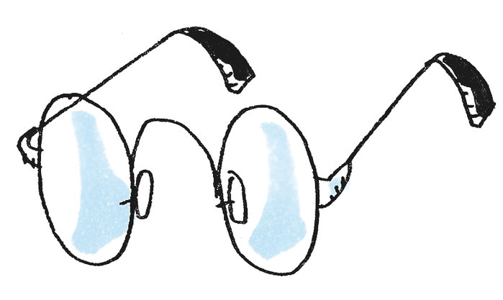

R = regional; N = national; I = International
R = regional; N = national; I = International

